**How to run the dashboard code**

System requirements: Python 3

Step 1. Click on dashboard.py to download the file.

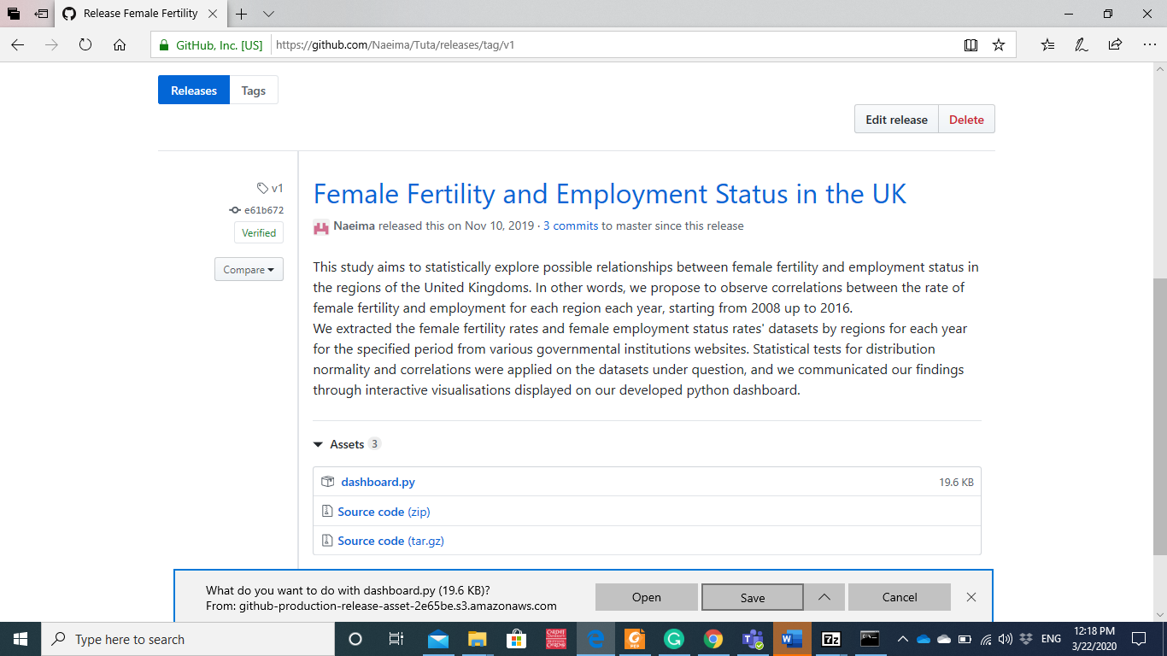

Step 2: Open folder where the file was downloaded

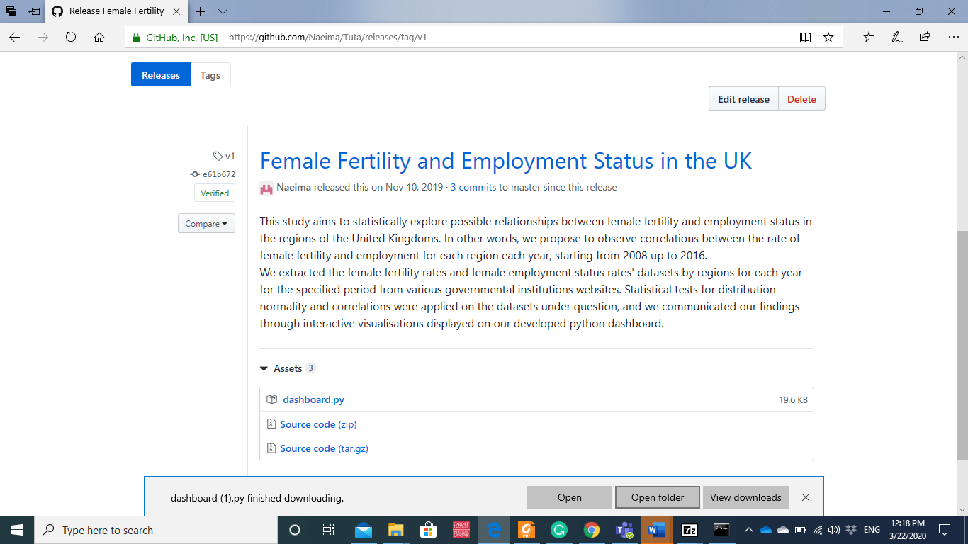

Step 3: at the top browser tap, type **cmd** to access the command prompt terminal.

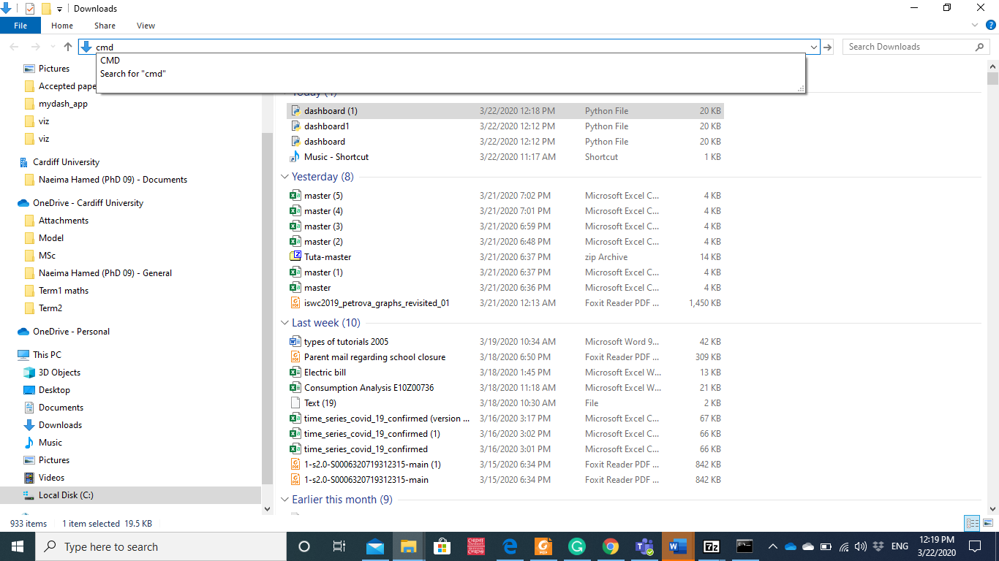

Step 4: at the cmd command line, type python dashboard.py

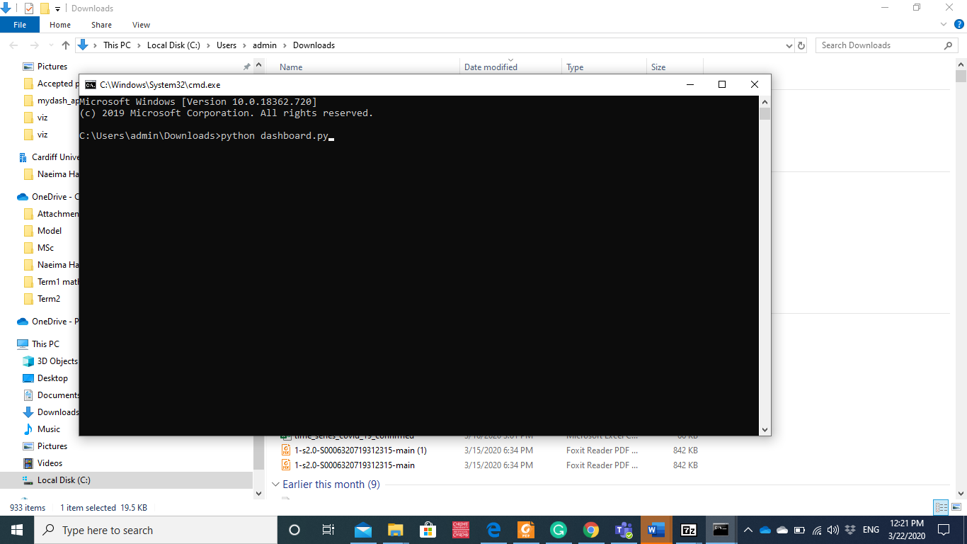

Step 5: the below output is executed

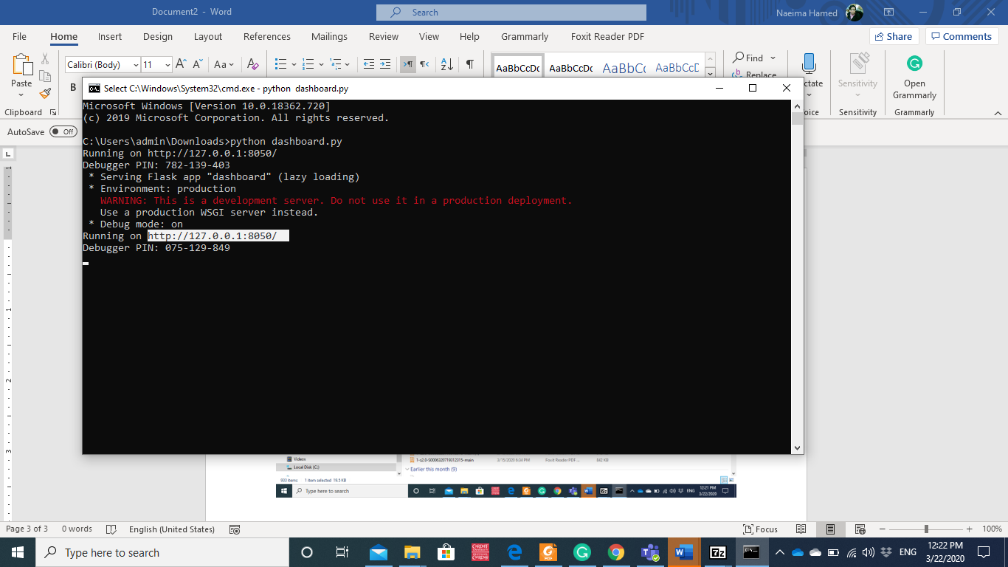

Step 6: copy the url highlighted on your chosen browser to see display the dashboard.

